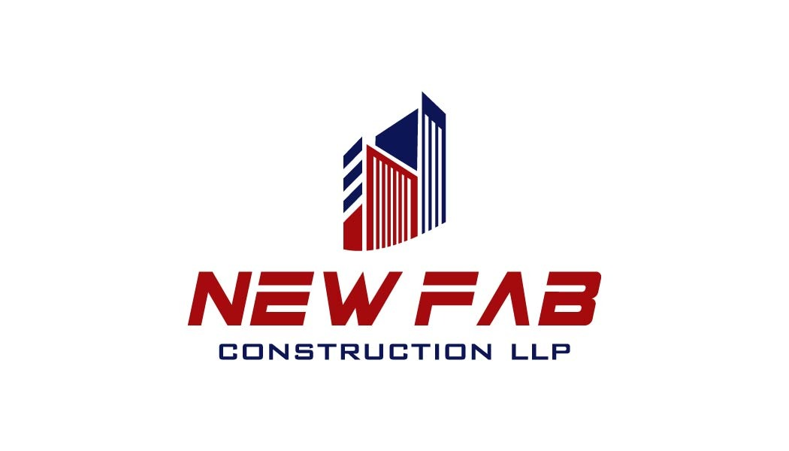
SAFETY POLICY

M/S NEW FAB CONSTRUCTION LLP, We are committed to achieve excellence in Safety and health of all our employees including employees of sub-contractor, visitors or any other agency involved in the NEW FAB work. We firmly believe that safe and healthy workmen render highest productivity and thus it is our endeavour to provide and maintain safe and healthful working conditions with ultimate objective of providing quality services in the assigned activities and continually strive for zero reportable incidents of accidents. We have a firm belief that through participation and cooperation of employees at various levels, we will be able to provide quality services. It is our prime concern that all employees come at site safely, work safely and return home safely, in addition to our concern for protection and the surrounding environment. We, therefore are committed to carry out hazards and risk identification analysis and provide all means in the processes & operations, detailing & providing safe operating procedure at site, providing safety devices, adequate and suitable personal protective equipment, approved quality input material, tools and ongoing education and training. To keep abreast of the latest techniques, we shall continually strive to identify and employ such techniques for identification of present and potential hazards to exercise timely and effective control measures primarily by line management and everyone concerned. We shall foster continual improvements and adopt best practices in HSE. For the purpose of visible commitments by the management towards the noble cause of protecting safety and health of the employees, we as a continuous measure, would provide necessary arrangements with periodical review, thus eliminating the obsolete and revising the existing arrangements. We are sincerely and seriously interested in augmenting and promoting the health services for the benefit of our employees. We value Safety as a fundamental human right. We are confident that employees at various levels shall discharge their assigned responsibilities as stipulated.

Junaid Panirwala Rehan kapadia
Managing Director
06.04.2026

